

THE HERITAGE

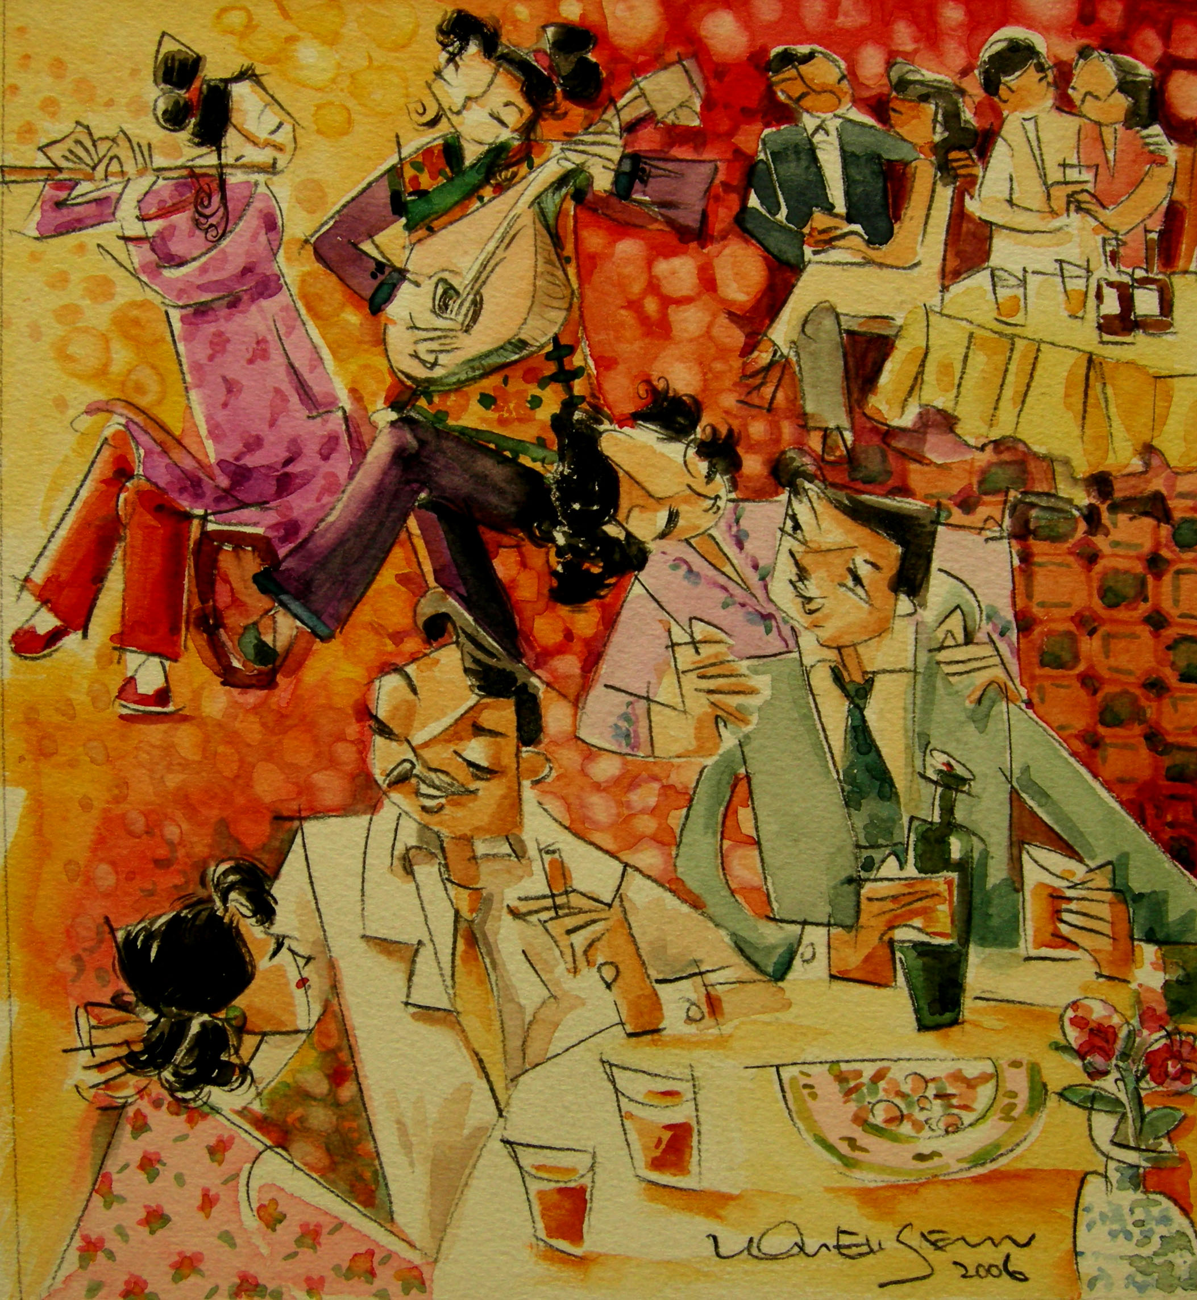

‘Pipa Girl’
The older babas preferred the parlours in which ‘pipa chai’ or singsong girls could be found.

